Title of Assignment
Name
Course and Section

Title of Paper
Every paper you write should start off with a title heading that services as an introduction to the paper. The introduction should be 3-5 sentences.
Presenting Concern
You will likely need to write about one full page or more (depending on your writing style) to fully address each question below. I would suggest including one paragraph per question. Start each paragraph off with a transition sentence that includes words from the rubric or question that you will be addressing in that paragraph (this will make it clear to the reader where you are addressing each prompt and rubric point). After you address the questions, remember to delete the question. Then review your work against the Rubric and “grade” your own paper to ensure you addressed each point. Remember to delete the screen shot of the rubric prior to submitting. Remember to utilize your sources to support your ideas as appropriate and follow APA guidelines. Proof read twice.
Identify which of this week’s theoretical approaches you will use to conceptualize the case and why.
What do you see as the client’s presenting concerns/basic conflicts?
Based upon the concerns you identified, discuss which you would address first and why based upon the theoretical approach.
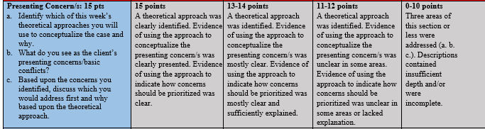
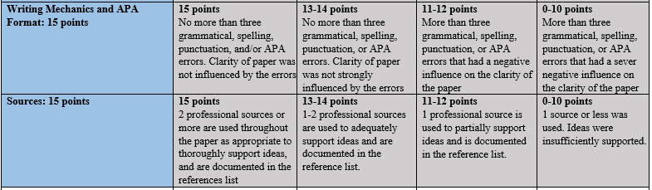
One Central Concept
You will likely need to write about one full page or more (depending on your writing style) to fully address each question below. I would suggest including one paragraph per question. Start each paragraph off with a transition sentence that includes words from the rubric or question that you will be addressing in that paragraph (this will make it clear to the reader where you are addressing each prompt and rubric point). After you address the questions, remember to delete the question. Then review your work against the Rubric and “grade” your own paper to ensure you addressed each point. Remember to delete the screen shot of the rubric prior to submitting. Remember to utilize your sources to support your ideas as appropriate and follow APA guidelines. Proof read twice.
Identify one central concept of the approach (other than any you previously use to answer the above question) and describe the central concept
Explain how the central concept is relevant to working with the client or understanding the case.
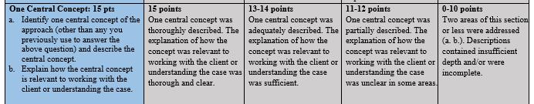
One Technique
You will likely need to write about one full page or more (depending on your writing style) to fully address each question below. I would suggest including one paragraph per question. Start each paragraph off with a transition sentence that includes words from the rubric or question that you will be addressing in that paragraph (this will make it clear to the reader where you are addressing each prompt and rubric point). After you address the questions, remember to delete the question. Then review your work against the Rubric and “grade” your own paper to ensure you addressed each point. Remember to delete the screen shot of the rubric prior to submitting. Remember to utilize your sources to support your ideas as appropriate and follow APA guidelines. Proof read twice.
Identify one strategy or technique you could use with the client and describe the strategy or technique
Discuss why you chose the technique for use with this client.
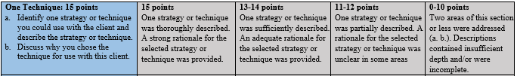
Dialogue
Provide an 5x5 (or longer) practice dialogue (5 counselor statements and 5 client statements) to give us a brief snap shot of how you would go about using the above strategy or technique. See the attached skills guide for some basic counseling skills that can assist you when implementing the selected strategy or technique.
Briefly explain the purpose (why you said what you said) behind each of your five statements
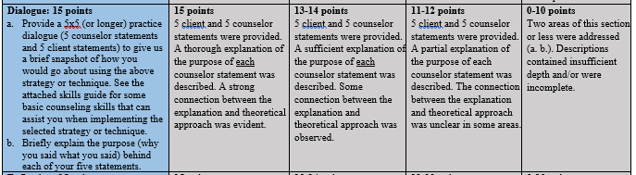
Reflection
You will likely need to write about one full page or more (depending on your writing style) to fully address each question below. I would suggest including one paragraph per question. Start each paragraph off with a transition sentence that includes words from the rubric or question that you will be addressing in that paragraph (this will make it clear to the reader where you are addressing each prompt and rubric point). After you address the questions, remember to delete the question. Then review your work against the Rubric and “grade” your own paper to ensure you addressed each point. Remember to delete the screen shot of the rubric prior to submitting. Remember to utilize your sources to support your ideas as appropriate (you likely won’t need to use a source in this reflection section) and follow APA guidelines. Proof read twice.
Provide at least one example of how you could apply any strategy, technique, or concept of this theoretical approach to an area of your life to learn something about yourself personally. Also, explain what you learned
What challenges did you encounter when attempting to apply an aspect of this theoretical approach to your life? Provide at least one example.
Did you notice any cultural limitations/obstacles to applying this approach to your life? Describe the cultural limitation or explain how the approach is culturally responsive.
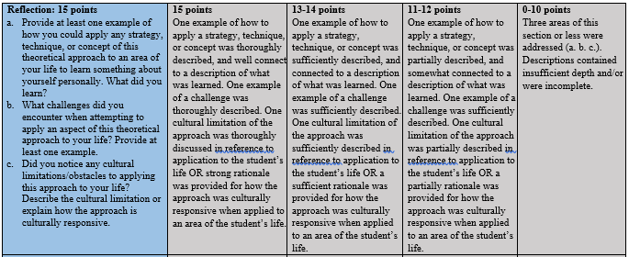

References
Tip: if you used the textbook as a source, look in the syllabus to see how it is cited.
Most of you will likely have used a journal article as your second professional source. See APA Owl Purdue for some citations tips. https://owl.english.purdue.edu/owl/resource/560/07/

